PASSPORTTM ACCOUNTABILITY SYSTEM

ORDER FORM for NAMETAGS
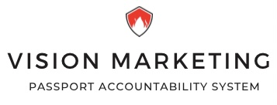  165 Crestview Crt, Barrington, IL 60010  Fax: (847) 304-1537  www.passportaccountability.com  info@passportaccountability.com | Shipping and Billing Address
 | Agency:
 | Address:
 | Phone: |  |  | Date:
 | Attention: |  |  | P.O.#:
NAMETAGS
LAST NAME (1st Initial ONLY on duplicate names) |  |  |  |  |  | Quantity
Continued on Next Page: → - OR - |  |  | TOTAL QUANITY:

MINIMUM ORDER $30.00 plus $8.95 SHIPPING AND HANDLING

